CS 340 Artificial Intelligence
Quiz # 3 Solution (CLO 2)
12 May, 2025
Total Marks :10
Name: No:

Q. The graph below is a constraint graph for a CSP that has only binary constraints. Initially, no variables have been assigned.
For each of the following scenarios, mark all variables for which the specified filtering might result in their domain being changed.

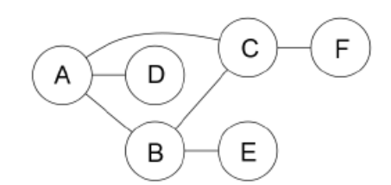

- A value is assigned to A. Domains of which variables might be changed because of running forward checking for A? Give full justification for your answer else no marks would be given. (5 marks)

Forward checking for A only considers arcs where A is the head. This includes A→B, A→C, A→D. Enforcing these arcs can change the domains of the tails i.e. variables B, C and D.

(b) A value is assigned to A. Domains for which variables might be changed because of enforcing arc consistency after this assignment? Give full justification for your answer else no marks would be given. (5 marks)

Enforcing arc consistency can affect any unassigned variable in the graph that has a path to the assigned variable. This is because a change to the domain of X results in enforcing all arcs where X is the head, so changes propagate through the graph. Thus in this case domain of all other variables (B, C, D, E, F) might change.

